**Document on VISISTAT**

## **Introduction to VISISTAT**

This document explains about the tracking the web visits and page visits when a contact (part of SmartTouch application or new contact) visits a webpage or clicks a link that is associated to a Form or Campaign This shall further help SmartTouch users in calculating the analytics for specific set of contacts.

VISISTAT is tool that helps in identifying this information and share the data related to the same. The sections drafted below highlight the configuration and the functionality as to how the data received from VISISTAT drives the scope.

**Functionality**

The functionality behind VISISTAT is to identify the IP’s based on the API calls (web services). The account(s) that are configured to VISISTAT in SmartTouch will communicate with the web services in order to identify and track the IP addresses associated to the contacts.

## **Flow involved in VISISTAT**



## **Scope Items**

**IP tracking for Forms and Campaigns**

The VISISTAT set-up is configured for each account that is available in SmartTouch. The set-up includes the identification of Forms and Campaigns for an account and tracking the IP addresses by identifying the views and clicks that are made by the contacts (either SmartTouch contacts or other contacts) for each and store them in the back-end.

**Mapping relation between the [Contacts] to the [Forms and Campaigns]**

Once the IP addresses are identified, the relation between the IP’s and the contact is made. These IP addresses are tracked and stored in a table at the back-end. If a new contact created in the system clicks on a Form or a Campaign sent to them, the IP address is matched with the records that are stored in the table. In case a match is found, the IP(s) is matched to that contact.

In this way, there can exist one-many or many-one relation between a contact and an IP address. In future if any response is received from the IP address(s) shall persuade the contacts analytics.

**Service development for VISISTAT response data**

For every account under SmartTouch, which is registered with VISISTAT, a key is generated in order to identify the account for the data communications.

*<Kindly add any other technical items that are required to fetch the data>*

**Integration of VISISTAT website links and the associated action triggers in the SmartTouch modules:**

**Lead Score:** The response that received from VISISTAT shall effect the Lead Score rules that are categorized under ‘Websites’ and the conditions are either ‘A contact visits a web site’ or ‘A contact visits a web page’.

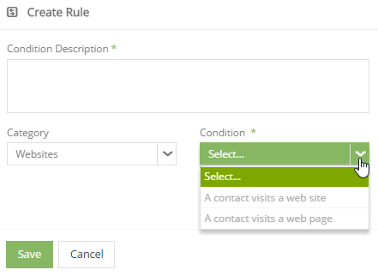

**E.g.:** Lead Score rule is defined as – Add ‘X’ score to a contact who visits a particular website/webpage.

Now when any contact(s) visit the mentioned webpage or website, the lead score is incremented as per the rule.

The functionality involved behind this is, the IP for the contact(s) in SmartTouch are tracked based on the web service data that is received from VISISTAT.

**Timeline:** The impacted contacts, configured as per any of the above rules shall see the same in their timeline as well.

**Automation:** Any of the workflow that involves the Lead Score rule as per the conditions stated above shall have an impact.

**E.g.:** Lead Score rule is defined as – Add ‘X’ score to a contact who visits a particular website/webpage.

Now when any contact(s) visit the mentioned webpage or website, the lead score is incremented as per the rule. Any workflow that is configured as per the rule is triggered for the associated contact(s).

The functionality involved behind this is, the IP for the contact(s) in SmartTouch are tracked based on the web service data that is received from VISISTAT.

**VISISTAT configuration tab in Account Settings**

This tab is available for the ST Administrator user and the Account Administrator user.

|  |  |
| --- | --- |
| **Field Name** | **Description** |
| Account Name | Field length 50char free text area.  Shall specify the name of the account. |
| VisiStat Key | Field length 50char free text area for entering the VISISTAT key configured for the account. |
| Status | Dropdown with values as Active and Inactive. |
| Notify the owner when contacts visit your website? | Single-select to specify the notification preference. |
| When should the owner be notified? | Single-select to specify the notification duration preference. |
| Notify Users | Live search text area that shall fetch the names of the users associated to that account. |
| Send notification alerts through | Multi-select. Preference as to how the notifications are to be sent. |

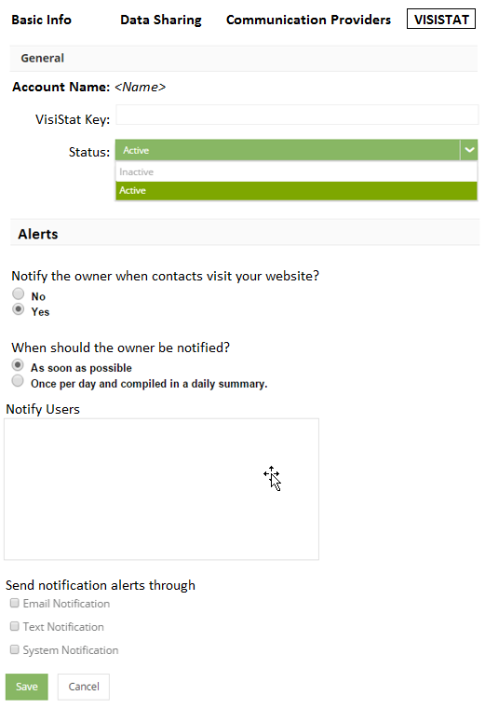

**History Data Processing for anonymous IP’s**

The history data regarding the IP’s for every account in SmartTouch (that is configured to VISISTAT) is tracked in tables at the back-end.

Campaign – The contacts and IP’s that are responsible for the campaign data in the form of Clicks; Views and Opens is tracked and saved in the system. Only the IP address is saved for those contact(s) accessing the campaign who are not registered in SmartTouch.

For such contacts, post registration, if a hit is identified from the IP that is stored in the table, the same is associated to the contact and shall be used in the future to track the lead score rules.

It is to be noted that, there can exist one-many or many-one relation between a contact and an IP address.

Forms – The contacts and IP’s that are responsible for the contacts that are inserted in to the system through the internet form submissions are tracked and saved in the system.

**Migration scripts for VISISTAT history data**

The migration scripts have to be written in order to fetch the data and proceed with the functionality as it is ongoing in Classic when migrated to NextGen.

**Post Beta Requirements**

* Multiple VISISTAT configurations for a single account in SmartTouch
* Reports and Dashboards for VISISTAT